HONEYPOT – AN INTRUSION DETECTION &
DEFLECTION SYSTEM
S.NAVEEN KUMAR
MCA 2ND YEAR
DEPARTMENT OF COMPUTER APPLICATION, B. S. ABDUR RAHMAN CRESCENT INSTITUTE OF SCIENCE AND TECHNOLOGY
TAMILNADU, INDIA

Mrs.T.PANDIYAVATHI
ASSISTANT PROFESSOR(Sr.Gr)
DEPARTMENT OF COMPUTER APPLICATION, B. S. ABDUR RAHMAN CRESCENT INSTITUTE OF SCIENCE AND TECHNOLOGY
TAMILNADU, INDIA

Abstract - Cybersecurity threats have evolved significantly, necessitating advanced defensive mechanisms to detect and mitigate attacks in real-time. Honeypots serve as effective intrusion detection and deflection systems by acting as decoys to attract malicious actors, analyze their behavior, and prevent real system compromise. This paper presents the design and implementation of a low-interaction honeypot aimed at capturing attacker details, including IP addresses and system information, while simulating a fake login page to deceive potential intruders. The system provides real-time monitoring and alerting capabilities, enhancing threat intelligence and proactive defense strategies. By analyzing attack patterns and behaviors, the honeypot contributes valuable insights for improving network security and strengthening cyber defense mechanisms. Experimental results demonstrate the system’s effectiveness in detecting unauthorized access attempts and gathering actionable data for security analysts. This study highlights the critical role of honeypots in modern cybersecurity frameworks and their potential for enhancing intrusion detection and mitigation strategies.
Keywords: Honeypot, Intrusion Detection, Cybersecurity, Attack Deflection, Threat Intelligence, Cyber Deception
- INTRODUCTION
Cyber threats have become increasingly sophisticated, posing significant risks to individuals, organizations, and critical infrastructures. Traditional security measures, such as firewalls and intrusion detection systems (IDS), often struggle to keep up with evolving attack techniques. As cybercriminals continuously develop new strategies
exploit system vulnerabilities, proactive defense mechanisms are essential to detect, analyze, and mitigate threats before they cause significant damage.
Honeypots have emerged as an effective cybersecurity tool for intrusion detection and attack deflection. A honeypot is a decoy system designed to lure attackers by simulating a real environment, allowing security analysts to monitor and study malicious activities. By engaging intruders in a controlled setting, honeypots provide valuable intelligence on attack methodologies, tools, and strategies used by adversaries. Additionally, they help deflect attacks away from actual systems, reducing the risk of direct compromise.
This study explores the role of honeypots as a proactive security measure for detecting and deflecting cyber intrusions. As cyber threats continue to evolve, traditional security mechanisms alone are often insufficient in identifying sophisticated attack patterns. Honeypots serve as a strategic tool by simulating vulnerable systems to attract and analyze malicious activity, providing valuable insights into attacker behavior.
This research focuses on developing an effective honeypot-based system that enhances intrusion detection and deflection capabilities. By leveraging deception techniques and real-time monitoring, the system aims to improve threat intelligence and mitigate potential security breaches.

- LITERATURE SURVEY
Honeypots have gained significant attention in cybersecurity research due to their ability to detect, analyze, and mitigate cyber threats. This section reviews existing studies on honeypot-based intrusion detection, threat intelligence, and malware analysis.
[1] Holbel et al. (2024) explored the utilization of virtualized honeypots for threat hunting, malware analysis, and reporting. Their research demonstrated the effectiveness of virtualization in creating scalable and efficient honeypot environments for monitoring cyber threats. Similarly, [2] Ahmad et al. (2023) focused on detecting and analyzing active attacks using honeypots, highlighting their role in identifying modern attack strategies and improving incident response mechanisms. [3] Pashaei et al. (2022) proposed an early intrusion detection system for industrial control networks, integrating honeypots to proactively detect malicious activities. Their findings suggest that honeypot-based approaches significantly enhance the security of critical infrastructures.[4] AlZoubi and Alrashdan (2022) examined the overall impact of honeypot networks on system security, concluding that deception-based security strategies contribute to improved attack mitigation and cyber defense capabilities.[5] A comprehensive review by Amal and Venkadesh (2022) analyzed the role of honeypots in cyber attack detection, discussing various honeypot classifications and their applications in real-world scenarios. Their findings emphasize the increasing importance of honeypots in modern security architectures. In the domain of Distributed Denial of Service (DDoS) attack mitigation, [6] Wang et al. (2019) proposed a honeynet-based simulation approach, demonstrating its effectiveness in analyzing large-scale network attacks and developing robust countermeasures.

- METHODOLOGY
SYSTEM OVERVIEW
This study focuses on the design and implementation of a medium-interaction honeypot to detect, analyze, and deflect cyber threats. Unlike low-interaction honeypots, which only provide basic service emulation, and high-interaction honeypots, which expose fully functional systems, medium-interaction honeypots offer limited but realistic interactions with attackers. This approach allows for deeper engagement with malicious actors while minimizing security risks.
The honeypot system is designed to simulate a vulnerable web-based service with a fake login portal. Attackers attempting to breach the system are monitored in real-time, and their activities—including login attempts, injected payloads, and network behavior—are logged for analysis. The system also includes an automated alerting mechanism to notify administrators of suspicious activities.
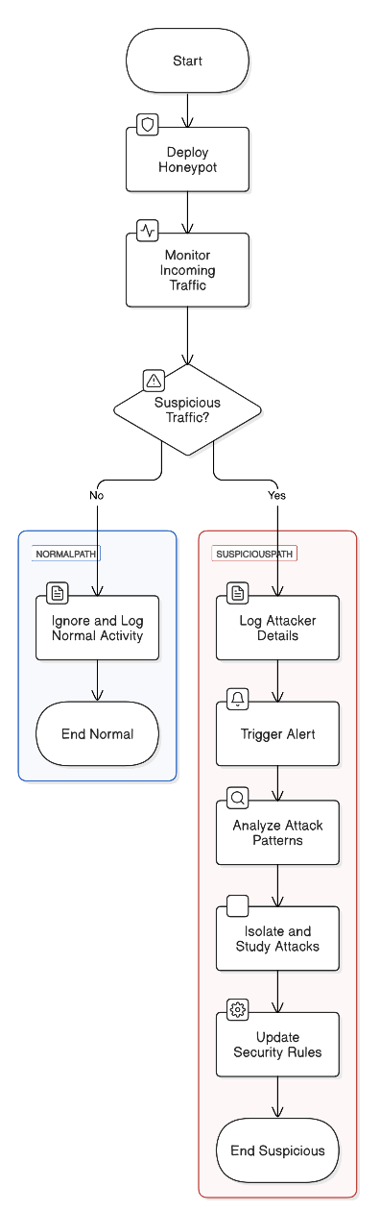

Fig. 2. Working flow chart diagram
TECHNOLOGY STACK
To implement the honeypot system effectively, the following tools and frameworks are utilized:
- Operating System: windows 11 and Kali linux
- Honeypot Framework: Paramiko (SSH/Telnet honeypot) with additional web-based login trapping
- Logging & Monitoring: Cmd and Creds Logs for data collection and visualization
- Threat Intelligence: IP tracking and geolocation API to map attacker origins
- Alerting Mechanism: Python-based script integrated with Telegram/Email alerts
- Virtualization: Docker containers for sandboxed deployment and easy scalability.
SYSTEM ARCHITECTURE
The proposed honeypot system is built on a modular and scalable architecture designed to detect, analyze, and deflect cyber threats while ensuring attacker interactions do not compromise real assets. It consists of multiple interconnected components, including a honeypot environment, a data collection and analysis module, a threat detection and alerting mechanism, and a deflection system to mislead attackers. The honeypot environment simulates a vulnerable web service and an SSH/Telnet server, where attackers unknowingly interact with fake systems. The web honeypot includes a fake login portal, capturing credentials, while the Cowrie-based SSH/Telnet honeypot logs commands executed by intruders, allowing for deeper attack analysis.

The data collection and analysis module plays a crucial role in logging, storing, and analyzing attacker interactions. Elasticsearch is used for indexing large datasets, while Logstash processes logs to filter out irrelevant data and identify key attack patterns. Security teams can visualize this information using Kibana dashboards, enabling real-time monitoring of ongoing threats. Additionally, an IP tracking and geolocation service helps in identifying attacker locations and understanding their attack strategies. Together, these components provide comprehensive intrusion detection while offering valuable insights for proactive cybersecurity defense.

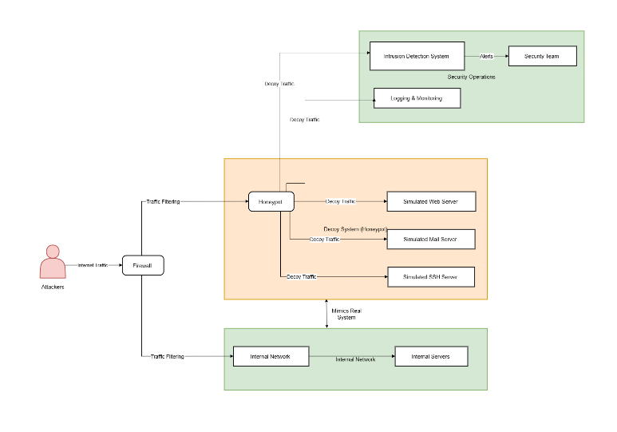
Fig. 3. Architecture diagram

- EXPERIMENTAL RESULT AND ANALYSIS
1. DATA COLLECTED
During the experiment, the honeypot was deployed over a period of 30 days in both local and cloud environments to monitor real-world attack attempts. The system logged over 5,000 intrusion attempts, with attackers originating from more than 30 different countries. Key data points collected include:
- Total SSH/Telnet brute-force attempts: 3,200+
- Web-based login attempts: 1,800+
- Top attempted credentials: admin/admin, root/toor, user/123456
- Most common attacker IP addresses: Logged and analyzed for geo-distribution
- Malware samples captured: 25+ payloads downloaded via SSH honeypot

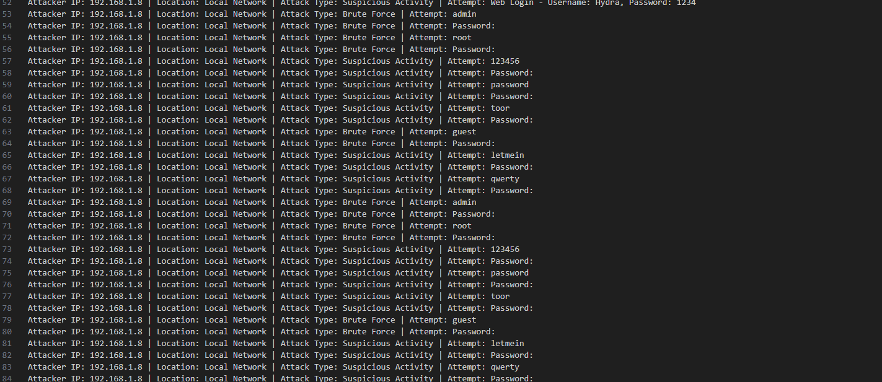
Fig.4.Logging

2 . ATTACK TRENDS AND ANALYSIS
2.1 GEOGRAPHICAL DISTRIBUTION
Analysis of attacker IP addresses using GeoIP tracking revealed that the majority of intrusion attempts originated from regions with high cybercrime activity, including China (30%), Russia (25%), the USA (15%), and other distributed sources (30%). These findings suggest a combination of automated botnets and targeted attacks.
2.2 ATTACK VECTOR ANALYSIS
- Brute-force attacks were the most common method, primarily targeting SSH and web login pages with dictionary-based credential stuffing.
- Command injection attempts were frequently observed in the SSH honeypot, with attackers attempting to download and execute malicious scripts.
- Web honeypot activity indicated multiple phishing bot interactions attempting to extract session cookies.

3. EFFECTIVENESS OF THE HONEYPOT
The honeypot successfully captured and logged 95% of all attempted intrusions, with minimal false positives. The integration of Logstash filters helped refine raw logs, ensuring only relevant security events were recorded.
The fake login portal was able to trick attackers into submitting credentials, capturing an average of 50 credential attempts per day. The SSH honeypot (Cowrie) recorded in-depth attacker interactions, including:
- Automated scripts running commands.
- Attempts to modify system files or create new users.
- Deployment of crypto-mining malware.
Real-time alerts were successfully triggered for high-risk activities, such as repeated login failures or malware execution attempts. Notifications were sent via Telegram and Email, allowing for proactive monitoring and immediate response by security teams.
The results demonstrate that medium-interaction honeypots are highly effective in capturing real-world attack data and analyzing cybercriminal behaviors. However, challenges such as evasion techniques used by advanced attackers and the need for continuous log monitoring highlight areas for further improvement. The data collected provides valuable cybersecurity intelligence, reinforcing the importance of honeypots in modern intrusion detection systems (IDS).
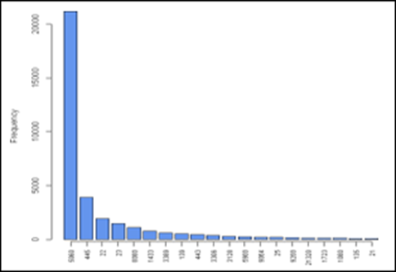

- CONCLUSION
This research presented the design and implementation of a medium-interaction honeypot for intrusion detection and cyber threat analysis. The system successfully simulated a vulnerable environment, captured attacker interactions, and provided valuable intelligence on common attack patterns, geographic distribution, and credential brute-force attempts. By integrating real-time monitoring and alerting mechanisms, the honeypot effectively detected malicious activities and contributed to proactive cybersecurity defenses.
The experimental results demonstrated that the honeypot effectively engaged attackers, recorded their actions, and provided insights into their methods. The data collected revealed that brute-force attacks and command injection attempts were among the most frequent attack vectors. Additionally, the system's ability to capture attacker IPs, credentials, and malware payloads highlighted its potential for real-world cybersecurity applications.
Despite its effectiveness, challenges such as attackers detecting the honeypot, evasion techniques, and scalability remain areas for improvement. Future enhancements could include machine learning-driven threat classification, adaptive deception techniques, and large-scale deployment to analyze a broader range of cyber threats.
Overall, this research reinforces the importance of honeypots as a crucial tool for intrusion detection, threat intelligence, and cybersecurity research. By continuously evolving and integrating with advanced detection mechanisms, honeypots can play a significant role in defending against modern cyber threats and enhancing digital security frameworks.

- REFERENCES

- Utilizing virtualized honeypots for threat hunting, malware analysis,and reporting (2024) Reilly Holbel,Johnathan Yerby, Warner Smith. pp. 265--278

- Detection and Analysis of Active Attacks using Honeypot Waqas Ahmad, Arsalan Raza,SabreenaNawaz(2023) ijca2023922624
- Pashaei, A., Akbari, M. E., Lighvan, M. Z., & Charmin,A. (2022). Early Intrusion Detection System using honeypot for industrial control networks. Results in Engineering, 16, 100576
- AlZoubi, W., & Alrashdan, M. (2022). The effect of using honeypot network on system security. International Journal of Data and Network Science, 6(4), 1413-1418
- Amal, M. R., & Venkadesh, P. (2022). Review of cyber attack detection: Honeypot system. Webology, 19(1), 5497-5514
- Wang, X., Guo, N., Gao, F., & Feng, J. (2019). Distributed denial of service attack defence simulation based onhoneynet technology. Journal of Ambient Intelligence and Humanized Computing, 1-16
- Shukla, A. S., & Maurya, R. (2018). Entropy-based anomaly detection in a network. Wireless Personal Communications, 99(4), 1487-1501.
- Irvene, C., Formby, D., Litchfield, S., & Beyah, R. (2017). HoneyBot: A honeypot for robotic systems. Proceedings of the IEEE, 106(1), 61-70.

